Grove - Moisture Sensor

|  |
| --- |
| **Contents**   [[hide](javascript:toggleToc())]   * [1 Introduction](http://seeedstudio.com/wiki/Grove_-_Moisture_Sensor#Introduction) * [2 Features](http://seeedstudio.com/wiki/Grove_-_Moisture_Sensor#Features) * [3 Specification](http://seeedstudio.com/wiki/Grove_-_Moisture_Sensor#Specification) * [4 Application Ideas](http://seeedstudio.com/wiki/Grove_-_Moisture_Sensor#Application_Ideas) * [5 Usage](http://seeedstudio.com/wiki/Grove_-_Moisture_Sensor#Usage) * [6 Version Tracker](http://seeedstudio.com/wiki/Grove_-_Moisture_Sensor#Version_Tracker) * [7 Resources](http://seeedstudio.com/wiki/Grove_-_Moisture_Sensor#Resources) * [8 Support](http://seeedstudio.com/wiki/Grove_-_Moisture_Sensor#Support) |

Introduction

This Moisture Sensor can be used to detect the moisture of soil or judge if there is water around the sensor, let the plants in your garden reach out for human help. They can be very to use, just insert it into the soil and then read it. with help of this sensor, it will be realizable to make the plant remind you : hey, i am thirsty now, please give me some water.

**Model:**[**SEN92355P**](http://www.seeedstudio.com/depot/grove-moisture-sensor-p-955.html?cPath=144_147)

[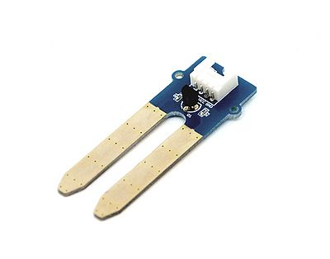](http://seeedstudio.com/wiki/File:Moisture_sensor_.jpg)

Features

* Soil moisture sensor based on soil resistivity measurement
* Easy to Use
* 2.0cmX6.0cm grove module

Specification

|  |  |  |  |  |  |
| --- | --- | --- | --- | --- | --- |
| **Item** | **Condition** | **Min** | **Typical** | **Max** | **Unit** |
| **Voltage** | - | 3.3 | / | 5 | V |
| **Current** | - | 0 | / | 35 | mA |
| **Output Value** | Sensor in dry soil | 0 | ~ | 300 | / |
| Sensor in humid soil | 300 | ~ | 700 | / |
| Sensor in water | 700 | ~ | 950 | / |

Application Ideas

* Botanical gardening
* Water sensor

Usage

This is a summary of the moisture sensor can be used to detect the moisture of the soil, when the soil moisture deficit, the sensor output value will decrease. You can know whether a plant needs water by observing the results that the sensor output. The following sketch demonstrates a simple application of sensing the moisture of the soil.

* Connect this module to one of analog port A0 of [Grove - Base Shield](http://www.seeedstudio.com/depot/grove-base-shield-p-754.html?cPath=132_134) with the 4 pin Grove cable, and then insert the Sensor into the soil or place it anywhere you want.
* Plug Grove - Base Shield into the Arduino/Seeeduino and connnect Arduino to PC via a USB cable.

The hardware installation as show below:   
[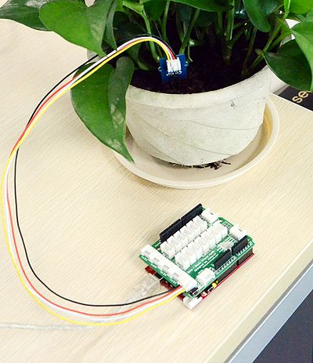](http://seeedstudio.com/wiki/File:Moisture1.jpg)  
**Note:**This sensor isn't hardened against contamination or exposure of the control circuitry to water and may be prone to electrolytic corrosion across the probes, so it isn't well suited to being left in place or used outdoors.

* Copy and paste code below to a new Arduino sketch.

int sensorPin = A0; // select the input pin for the potentiometer

int sensorValue = 0; // variable to store the value coming from the sensor

void setup() {

// declare the ledPin as an OUTPUT:

Serial.begin(9600);

}

void loop() {

// read the value from the sensor:

sensorValue = analogRead(sensorPin);

delay(1000);

Serial.print("sensor = " );

Serial.println(sensorValue);

}

* Upload the code, Please click [here](http://www.seeedstudio.com/wiki/Upload_Code) if you do not know how to upload.
* The Result in different condition after open the serial monitor:

|  |  |  |  |
| --- | --- | --- | --- |
| [No load.jpg](http://seeedstudio.com/wiki/File:No_load.jpg) | [Dry soil.jpg](http://seeedstudio.com/wiki/File:Dry_soil.jpg) | [Humility soil.jpg](http://seeedstudio.com/wiki/File:Humility_soil.jpg) | [IN water.jpg](http://seeedstudio.com/wiki/File:IN_water.jpg) |
| Sensor in air | Sensor in dry soil | Sensor in humid soil | Sensor in water |

Version Tracker

|  |  |  |
| --- | --- | --- |
| **Revision** | **Descriptions** | **Release** |
| v0.9b | Initial public release | 13,Sep,2011 |

Resources

* [Grove-_Moisture_Sensor_Eagle_File](http://www.seeedstudio.com/wiki/File:Grove-_Moisture_Sensor_Eagle_File.zip)